200888 NYSERDA O&R Challenge

Smarter Inverter and Advanced Distribution Management System (ADMS) Integration Project

Supported by

**New York State Energy Research and Development Agency (NYSERDA)**

**PON 4128 - NYSERDA Agreement No: 149165**

**Report B**

**“Power Hardware-in-the-Loop Experimental   
Smart Inverter Testing Environment at RPI”**

**Rensselaer Polytechnic Institute**

**110 8th Street**

**Troy, NY 12180-3590**

**September 25, 2022**

Authors:

**Hao Chang, Prof. Luigi Vanfretti**

**ALSET Lab,**

**Electrical, Computer and Systems Engineering Department**

RPI Principal Investigator/Project Manager: Luigi Vanfretti

Telephone: 518-276-2378, Email: vanfrl@rpi.edu

NYSERDA Project Manager

Michael Razanousky

SGS Project Manager

Yusef Orest

**Introduction** **4**

**1. General Testing and Equipment Setup** **5**

1.1. OP1400 Power Amplifier 5

1.2. DC Power Supply 6

1.3. SMA Inverter 7

1.4. Metering 8

**2. Constant Power Factor** **12**

2.1. Objective 12

2.2. Setup and procedure 12

2.3. Results 13

2.3.1. Unity Power Factor 13

2.3.2. Overexcited Power Factor 0.95 14

2.3.3. Overexcited Power Factor 0.9 16

2.3.4. Underexcited Power Factor 0.95 17

2.3.5. Underexcited Power Factor 0.9 19

2.4. Observations 20

**3. Constant Reactive Power** **21**

3.1. Objective 21

3.2. Setup and procedure 21

3.3. Results 22

3.3.1. Underexcited 750Var 22

3.3.2. Underexcited 1500W 23

3.3.3. Underexcited 2250W 24

3.3.4. Overexcited 750W 24

3.3.5. Overexcited 1500W 25

3.3.6. Overexcited 2250W 26

**4. Voltage-Var** **26**

4.1. Objective 26

4.2. Setup and procedure 27

4.3. Result 29

**5. Voltage-Watt** **30**

5.1. Objective 30

5.2. Setup and procedure 30

5.3. Result 32

**6. Voltage Ride Through** **33**

6.1. Objective 33

6.2. Setup and procedure 33

6.3. Result 34

**7. Return to Service** **35**

7.1. Objective 35

7.2. Setup and procedure 36

7.3. Result 36

**8. Summary of Test Results** **37**

**9. Bibliography - References** **38**

# 

# Introduction

This report contains a detailed description of the test results obtained in the NYSERDA PON4128 project, entitled “Power Hardware-in-the-Loop Experimental Smart Inverter Testing Environment at RPI”, performed by Rensselaer Polytechnic Institute with the support and guidance of Smarter Grid Solutions. The project is supported by the New York State Energy and Research Development Authority (NYSERDA) under PON 4128 - NYSERDA, Agreement No: 149165..

The experiments conducted in this report follow the “IEEE Standard Conformance Test Procedures for Equipment Interconnecting Distributed Energy Resources with Electric Power Systems and Associated Interfaces,” i.e. the IEEE 1547.1-2020 standard.

To verify the correct installation of testing equipment and the configuration of the SMA smart inverter, there are 6 separate tests conducted and documented in the following sections, which correspond to the smart inverter control functionalities under test:

* Constant Power Factor;
* Constant Reactive Power;
* Voltage Var;
* Voltage Watt;
* Voltage Ride Through and
* Return to Service.

Carrying out these tests allows for validating the capabilities of the testing environment setup and the smart inverter functionalities. With the successful test results documented herein, it becomes possible to enter into the next phase of this project, which consists of testing the integration of the smart inverter with SGS’s DERMS system.

For more detailed information about the testing environment please refer to Report A.

# General Testing and Equipment Setup

In this section, the user interfaces for the equipments used in all testing experiments are introduced. The following 4 equipments are used to control the tests and perform the observations needed to verify the functionality of the SMA inverter.

## OP1400 Power Amplifier

For this project the OP1400 amplifier is emulating the power grid that the inverter is connected to. The user interface below shows the control panel of the OP1400 power amplifier running in parallel with a real-time simulator to control and monitor the amplifier's status.

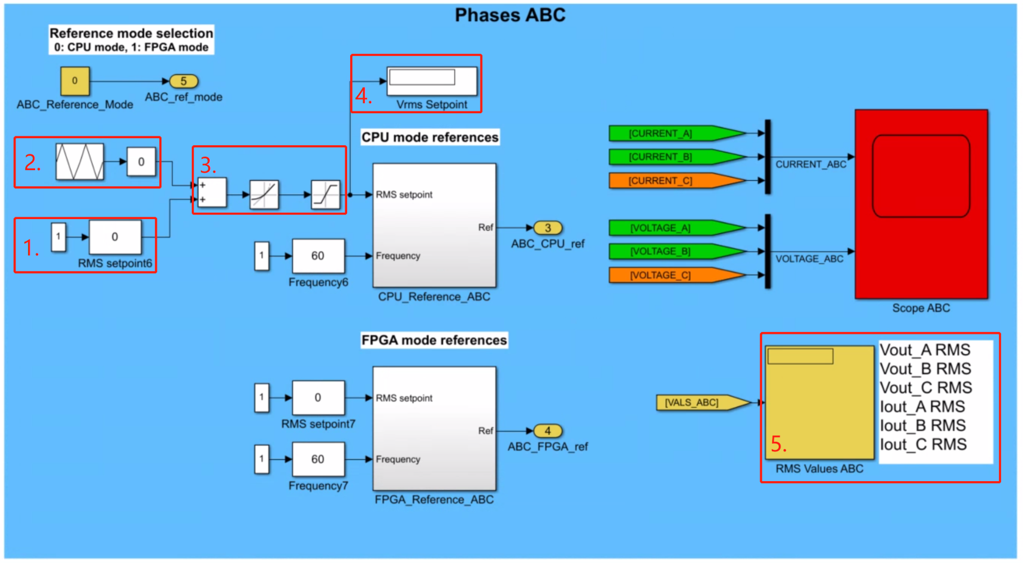

*Figure 1: OP1400 Power Amplifier UI*

In the figure above, enclosed in red squares and numbered, are the different experiment control and monitoring functions used to conduct the tests:

1. 3 Phase RMS Voltage Setpoint
2. Automated RMS Voltage Setpoint Adjustment
3. Slew Rate and Saturation Limiter
4. Current RMS Setpoint
5. Current RMS Voltage and Current for Each Phase (Monitoring)

The figure above is the control panel of the amplifier. In the following experiments, the 3-Phase RMS Voltage Setpoint is used to control the input voltage for the inverter to conduct High/Low voltage ride-through. The Automated RMS Voltage Setpoint Adjustment is used to automatically change the input voltage for the inverter to plot Volt-Watt and Volt-Var graphs. The Slew Rate limiter is necessary since during previous experiments a fast-changing voltage will trip the power amplifier due to autotransformer inrush current. The Saturation limiter avoids user input errors exceeding amplifier and inverter voltage limitations. The voltage saturates 160Vrms L-N. Thus the voltage can reach 692V L-L on the high side of the autotransformer which is sufficient for all of the testing procedures.

## DC Power Supply

The Photovoltaic Power Profile Emulation (PPPE) software automatically calculates solar array voltage and current profiles based on user-defined parameters. The figure below shows the user interface for MagnaDC PPPE software.

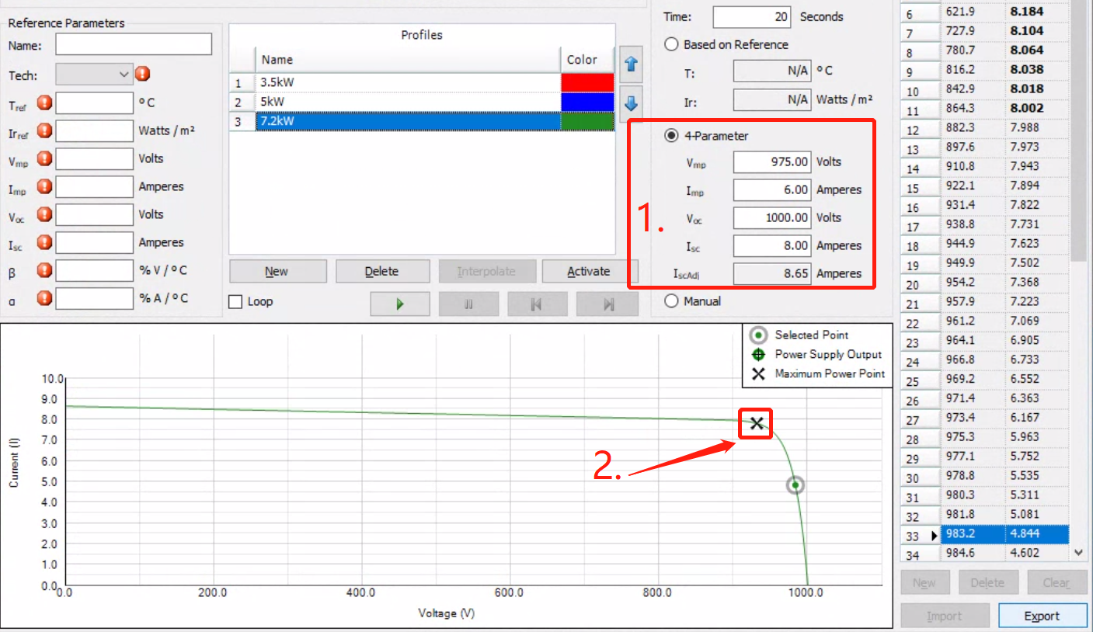

*Figure 2: DC Power Supply UI*

Since the experiments do not require change on the DC side and the maximum output real power of the inverter is set to 3kW, the profile in box 1 is sent to the DC power supply to have a maximum of 7.2kW(shown in box 2. MPP) power profile for the solar panel is used in all the experiments.

## 

## SMA Inverter

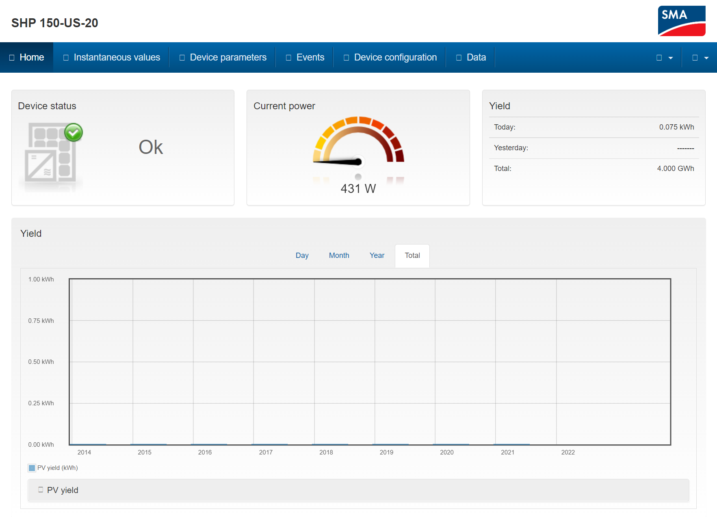

*Figure 3: SMA Inverter UI*

The SMA inverter is the EUT (equipment under test) for all the tests carried out and documented below. The inverter is configured through its embedded server user interface shown in the figure above. On the home page, the current output power and device status are displayed. The Device Parameters tab is where all the configuration for the inverter is located at. In the following experiments, the detailed settings are all displayed and configured through the Device parameter tab on the home page.

## 

## Metering

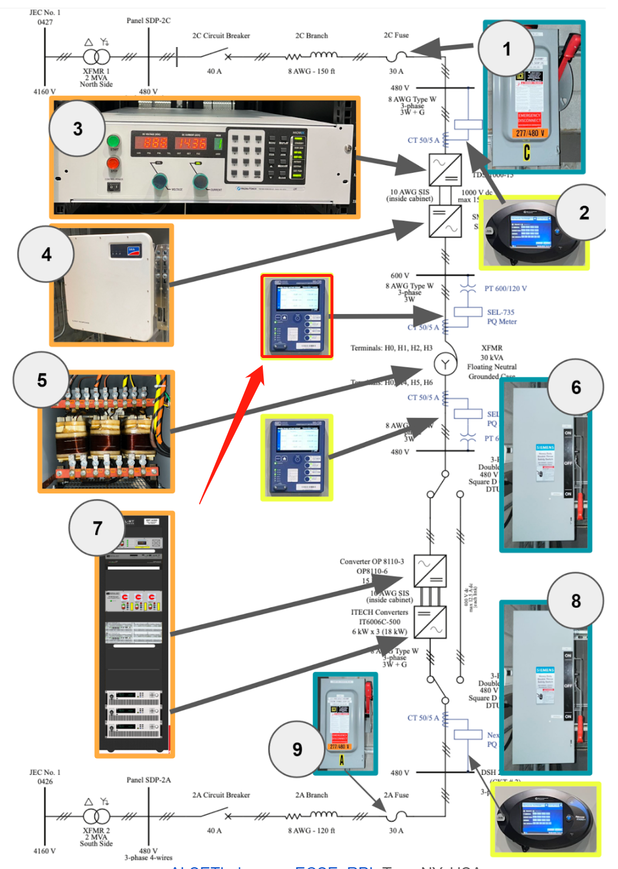

*Figure 4: Equipment Single Line Diagram*

To avoid any distortions introduced by the autotransformer, all the metering in this report is done by the SEL-735 in the red box shown in the figure above. The current transformer used by this meter has limited accuracy when measuring large currents. The error causes nonlinear phase and amplitude errors. Thus when the meter is calibrated at a high current, it tends to present a larger error at low currents. The calibration process is documented at the end of this section.

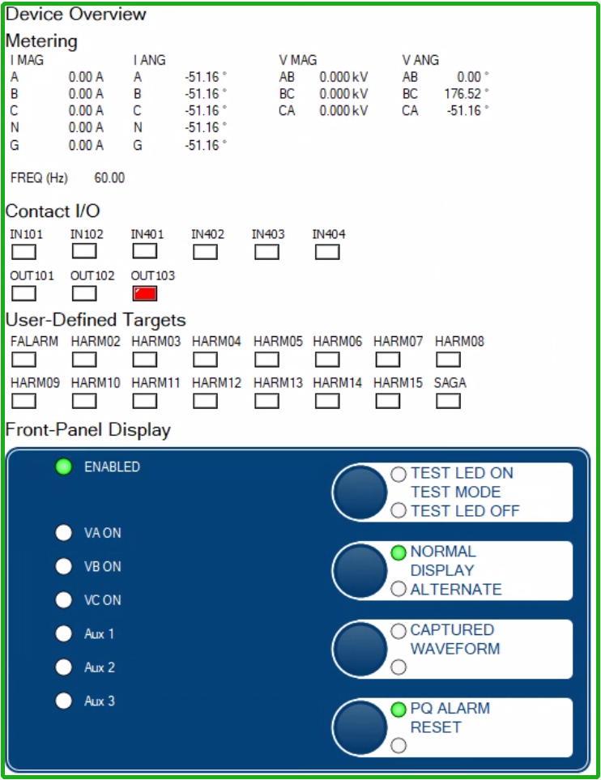

*Figure 5: Meter User Interface*

The figure above shows a screenshot of the meter’s graphical interface including measurements. All of the meter measurement screenshots for each test reported in this document were directly taken from the meter through SEL’s software to avoid any delay and/or synchronization issues in data acquisition. An example of such screenshots is shown below:

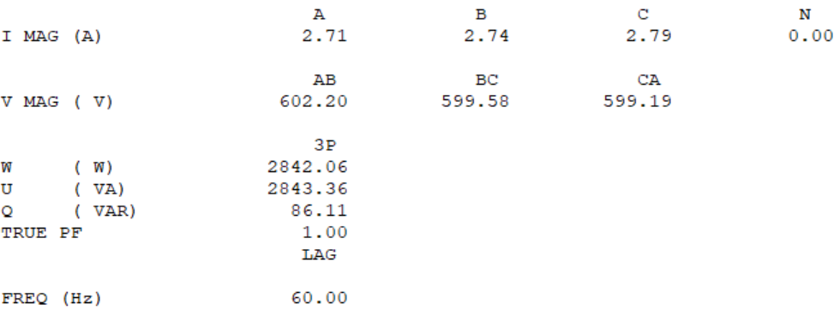

*Figure 6: Meter Measurement*

In this report, the meter measurements will be presented in the format shown in the above figure. The current, voltage, real power, apparent power, reactive power, and power factor are displayed to evaluate the status of the inverter.

In the sequel, the meter calibration steps are introduced. The process is started by configuring the inverter through its graphical interface (homepage):

1. The inverter is energized (see figure below) and set the output power for the inverter to 3kW. Since the amplifier is capable of going up to 5kVA, 3kW is chosen to leave some room for reactive power. Verify the reactive power stabilization is set to off.
2. Next, we verify the power output displayed on the homepage inverter’s embedded server. The power output is 2,910W±10W,

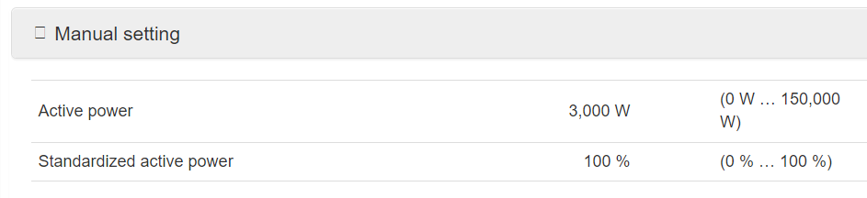

*Figure 7: Active Power Setting*

1. The Tek oscilloscope is used to verify the phase of the voltage and output current. In the above figure, the current is in phase with voltage which verifies the inverter is outputting zero reactive power.

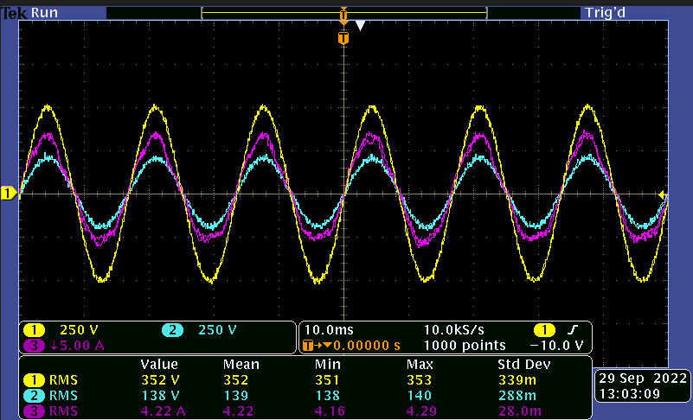

*Figure 8: Yellow-Transformer Highside Voltage Blue-TF Lowside V Pink-Inverter Current*

1. In the SEL’s software meter setting, the angle correction for the current transformer is adjusted until the true power factor reaches 1.



*Figure 9: Meter Measurement*

1. From the above figure, we can verify the meter is calibrated at high current working conditions.

# 

# Constant Power Factor

“This test verifies the EUT’S operation at a fixed power factor is compliant with 5.3.2 of IEEE Std 1547-2018. This test verifies the EUT’s response to changes in voltage magnitude and power when connected to an ac test source.” (IEEE-SASB Coordinating Committees)

## Objective

In the following test, the Constant p.f. mode of the inverter will be tested. From the web UI introduced in section 1.3., the power factor is set to be constant. The meter reading will be recorded after the inverter finishes adjusting the output power(reach a steady state). With the observation, we can verify if the inverter is outputting and maintaining the desired active and reactive power.

## Setup and procedure

The setting of the inverter from the web server is introduced to document any configuration change.



*Figure 10: Active Power Manual Setting*

From the above figure, the inverter is set to output constant active power at 3kW.

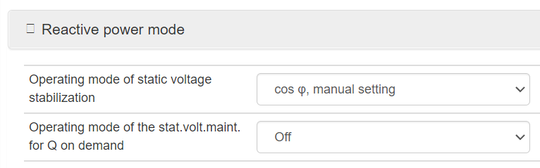

*Figure 11: Reactive Power Mode Setting*

The reactive power mode of the inverter is set to constant cos(phi) which is the power factor.

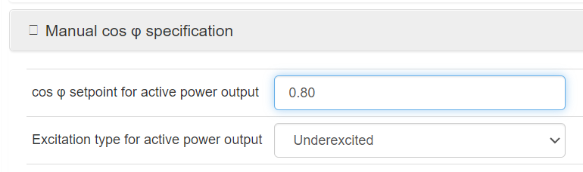

*Figure 12: P.F. Manual Setting*

For the following test, the cos(phi) and excitation type are adjusted according to different test requirements. In total 5 different combinations are documented in this report.

## Results

The test results are presented in the following section: Unity p.f., Overexcited 0.95, Overexcited 0.9, Underexcited 0.95, Underexcited 0.9

### Unity Power Factor

The inverter is configured to have a Unity power factor.

$cos(φ)=1$



*Figure 13: Meter Measurement*

The above figure shows the inverter generating around 3kW and the power factor is 1 as we expected. Since the SMA inverter is capable of generating 150kW, 158W of error is within the tolerance.

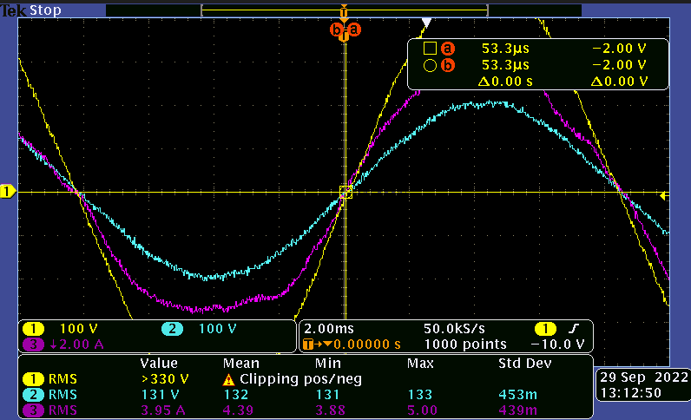

*Figure 14: Yellow-Transformer Highside Voltage Blue-TF Lowside V Pink-Inverter Current*

The oscilloscope shows the current is in phase with the voltage which indicates an unity power factor.

### Overexcited Power Factor 0.95

The inverter is configured to have lagging 0.95 p.f.

$cos(φ)=0.95$

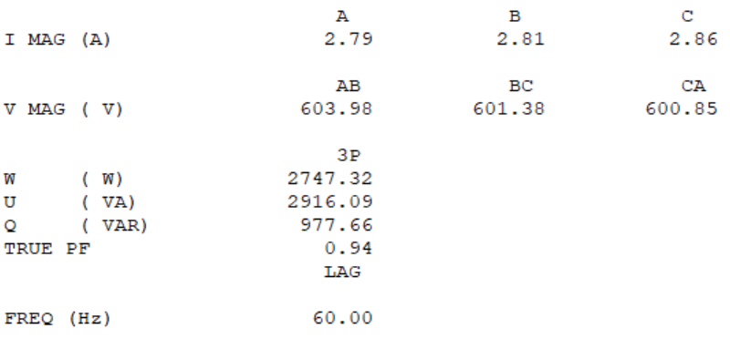

*Figure 15: Meter Measurement*

$cos(φ)=0.95$

$φ=18.2^{o}$

$W_{Real}=3000W$

$Q_{Reactive}=tan(18.2^{o}){*W_{Real}=986Var}_{}$

${U^{}}_{Apparent}=\sqrt{{W^{2}}_{Real }+{Q^{2}}_{Reactive}}=3157VA$

| Power | Desired | Measured | Error |
| --- | --- | --- | --- |
| Real | 3000W | 2747 W | 8.4% |
| Apparent | 3162 VA | 2916 VA | 7.8% |
| Reactive | 986Var | 977Var | 0.9% |
| P.f. | 0.95 | 0.94 | 1% |

From the above calculations, the measured real, apparent and reactive power is as expected and within a reasonable tolerance.

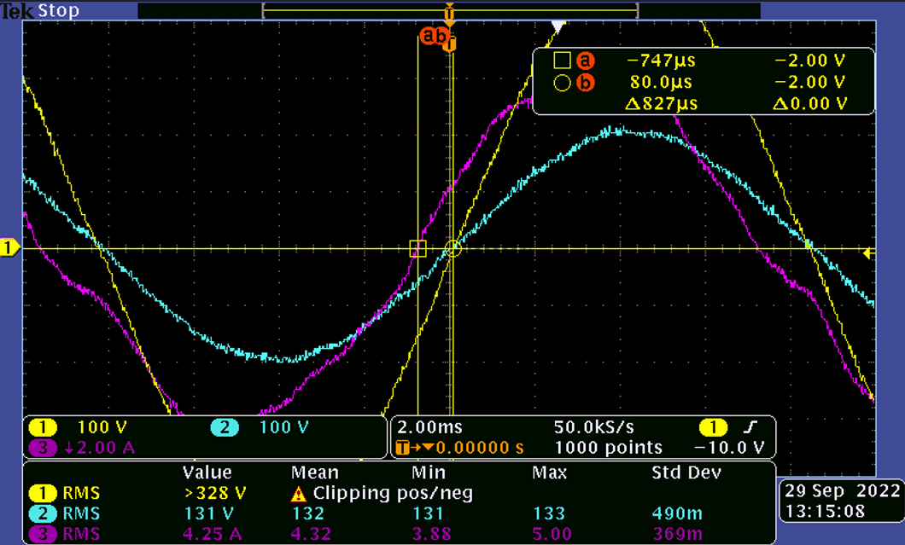

*Figure 16: Yellow-Transformer Highside Voltage Blue-TF Lowside V Pink-Inverter Current*

The oscilloscope is used to verify the lag angle. From the measurement, the time lag is 827 microseconds.

$φ=360*0.827ms*60Hz=17.8^{o}$

The measured lag angle is close to the desired angle. The error could be introduced by measurement error since the current waveform is slightly distorted. The measurement here is to cross-check the measurement from the meter.

### Overexcited Power Factor 0.9

The inverter is configured to have a lagging 0.9 p.f.

$cos(φ)=0.9$

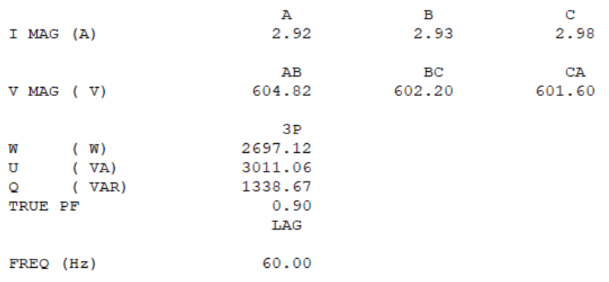

*Figure 17: Meter Measurement*

$cos(φ)=0.9$

$φ=26.8^{o}$

$W_{Real}=3000W$

$Q_{Reactive}=tan(25.8^{o}){*W_{Real}=1450Var}_{}$

${U^{}}_{Apparent}=\sqrt{{W^{2}}_{Real }+{Q^{2}}_{Reactive}}=3332VA$

| Power | Desired | Measured | Error |
| --- | --- | --- | --- |
| Real | 3000W | 2697W | 10.1% |
| Apparent | 3332VA | 3011 VA | 9.6% |
| Reactive | 1450Var | 1338Var | 7.7% |
| P.f. | 0.9 | 0.9 | 0% |

From the above calculations, the measured real, apparent and reactive power are as expected and within reasonable tolerance. The measured power factor is 0.9.

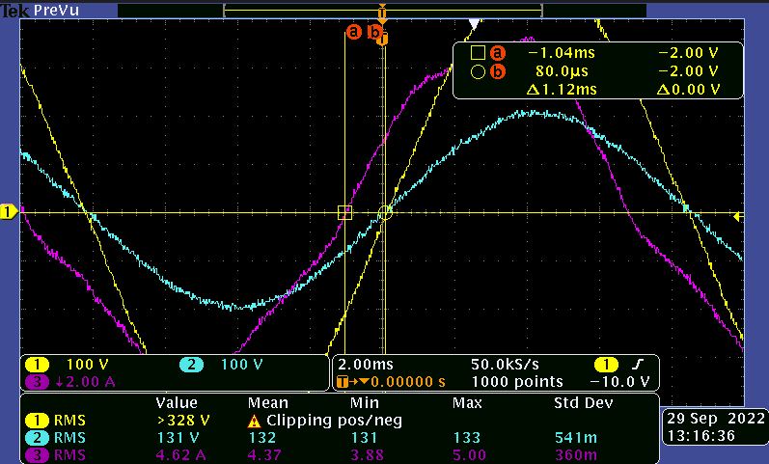

*Figure 18: Yellow-Transformer Highside Voltage Blue-TF Lowside V Pink-Inverter Current*

The oscilloscope is used to verify the lag angle. From the measurement, the time lag is 1.12 milliseconds.

$φ=360*1.12ms*60Hz=24^{o}$

The measured lag angle is close to the desired angle.

### Underexcited Power Factor 0.95

The inverter is configured to have leading 0.95 p.f.

$cos(φ)=-0.95$

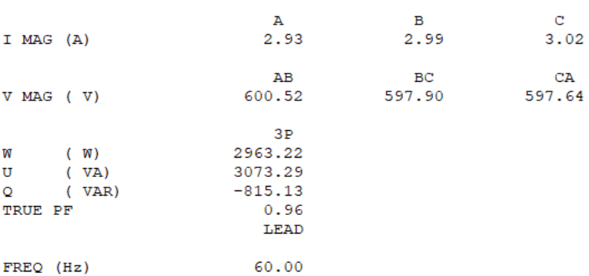

Figure 19: Meter Measurement

$cos(φ)=-0.95$

$φ=-18.2^{o}$

$W_{Real}=3000W$

$Q_{Reactive}=tan(-18.2^{o}){*W_{Real}=-986Var}_{}$

${U^{}}_{Apparent}=\sqrt{{W^{2}}_{Real }+{Q^{2}}_{Reactive}}=3157VA$

| Power | Desired | Measured | Error |
| --- | --- | --- | --- |
| Real | 3000W | 2747 W | 8.4% |
| Apparent | 3162 VA | 2916 VA | 7.8% |
| Reactive | -986Var | -815Var | 17% |
| P.f. | 0.95 | 0.96 | 1% |

From the above calculations, the measured real, apparent and reactive power are as expected and within a reasonable tolerance.

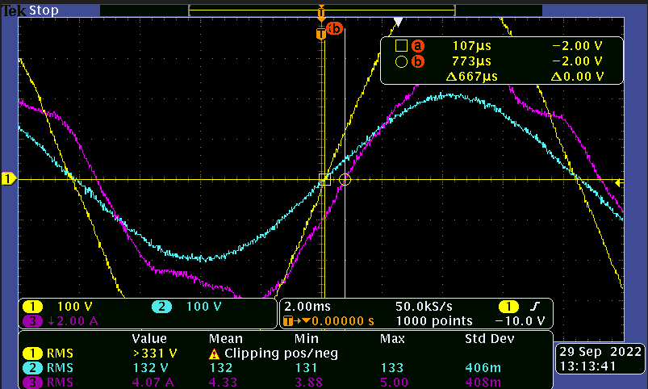

*Figure 20: Yellow-Transformer Highside Voltage Blue-TF Lowside V Pink-Inverter Current*

The oscilloscope is used to verify the lead angle. From the measurement, the time lead is 667 microseconds.

$φ=360*0.667ms*60Hz=14^{o}$

The measured lag angle is not close to the desired angle. From the figure above we can see the current waveform is much more distorted than the lagging case. From the scope measurement, simply the zero crossing point is taken as the reference point when calculating the time lead, which is not an effective way to estimate phase shift when the wave is heavily distorted. We can conclude from the above measurement that either the inverter is not effective in absorbing reactive power or that the autotransformer introduces nonlinearities in the current waveform and thereby affecting the calculations for verification above.

### Underexcited Power Factor 0.9

The inverter is configured to have leading 0.9 p.f.

$cos(φ)=-0.9$

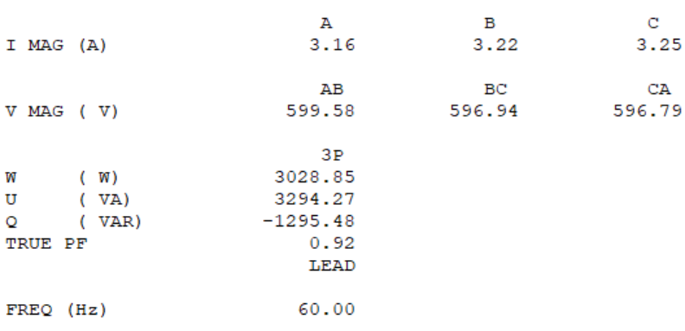

*Figure 21: Meter Measurement*

$cos(φ)=-0.9$

$φ=-26.8^{o}$

$W_{Real}=3000W$

$Q_{Reactive}=tan(25.8^{o}){*W_{Real}=-1450Var}_{}$

${U^{}}_{Apparent}=\sqrt{{W^{2}}_{Real }+{Q^{2}}_{Reactive}}=3332VA$

| Power | Desired | Measured | Error |
| --- | --- | --- | --- |
| Real | 3000W | 2697W | 10.1% |
| Apparent | 3332VA | 3011 VA | 9.6% |
| Reactive | -1450Var | -1295Var | 10.7% |
| P.f. | 0.9 | 0.92 | 2% |

From the above calculations, the measured real, apparent and reactive power is as expected and within a reasonable tolerance. The measured power factor is 0.92.

## Observations

The overall constant power factor performance is consistent with our expectations and satisfies the standard’s specifications. Identified discrepancies attributed to errors in the experiment that are mainly caused by nonlinear behavior of the autotransformer and measurement inaccuracy (current and voltage transformer quality).

# Constant Reactive Power

“This test verifies the EUT’S operation at a constant reactive power setting is compliant with 5.3.5 of IEEE Std 1547-2018 and the reactive power capabilities of the EUT defined in5.2 of IEEE Std 1527-2018. This test verifies the EUT’s response to changes in voltage magnitude and power when connected to an ac test source.” (IEEE-SASB Coordinating Committees)

## Objective

In the following test, the Constant reactive power mode of the inverter will be tested. From the web UI introduced in section 1.3. The reactive power is set to be constant. The meter reading will be recorded after the inverter finishes adjusting the output power(reach steady state). With the observation, we can verify if the inverter is outputting and maintaining the desired active and reactive power.

## Setup and procedure

The setting of the inverter from the web server is introduced to document any configuration change.

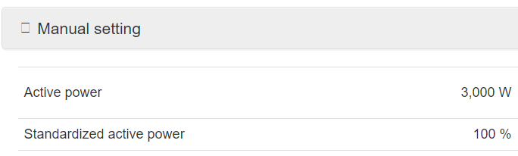

*Figure 22: Active Power Manual Setting*

From the above figure, the inverter is set to output constant active power at 3kW.

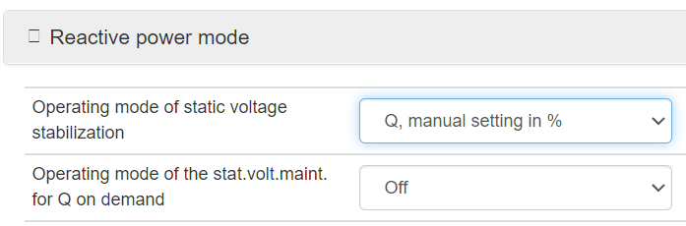

*Figure 23: Reactive power Mode*

The Operating mode of static voltage stabilization is set to manual control Q.

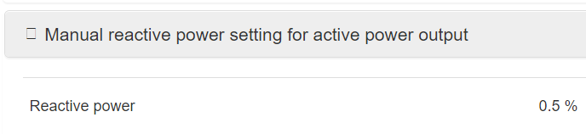

*Figure 24: Reactive Power Output*

For the following test, the percentage of reactive power is adjusted according to different test requirements. In total 6 different combinations are documented in this report.

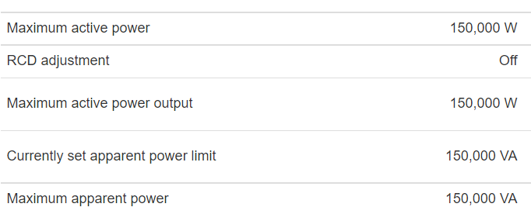

*Figure 25: Maximum Power Setting*

The maximum apparent power is 150kVA. Since we are only able to set the reactive power as a percentage in web UI, the 0.5%, 1%, 1.5%, -0.5%, -1% and -1.5% are chosen to test the constant reactive power mode of the inverter.

## Results

### Underexcited 750Var

$Q_{Reactive}=-0.5\%*150kVA=-750Var$

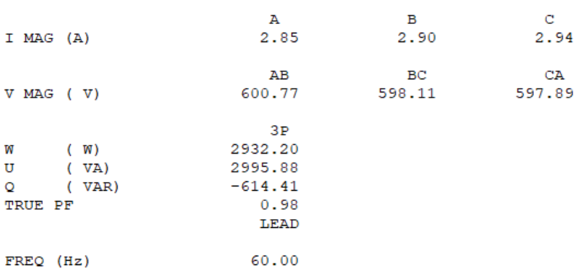

*Figure 26: Meter Measurement*

From the above figure, the measured reactive power is -614Var.

| Power | Desired | Measured | Error |
| --- | --- | --- | --- |
| Real | 3000W | 2932W | 2.2% |
| Apparent | 3092VA | 2995 VA | 3.1% |
| Reactive | -750Var | -614Var | 18.1% |

From the above calculations, the measured real, apparent, and reactive power are as expected and within a reasonable tolerance. The error of the reactive power is analyzed in section 2.3.4.

### Underexcited 1500W

$Q_{Reactive}=-1\%*150kVA=-1500Var$



*Figure 27: Meter Measurement*

From the above figure, the measured reactive power is -1295Var.

| Power | Desired | Measured | Error |
| --- | --- | --- | --- |
| Real | 3000W | 3028W | 1% |
| Apparent | 3354VA | 3294VA | 1.7% |
| Reactive | -1500Var | -1295Var | 13.6% |

From the above calculations, the measured real, apparent, and reactive power are as expected and within a reasonable tolerance.

### Underexcited 2250W

$Q_{Reactive}=-1.5\%*150kVA=-2250Var$

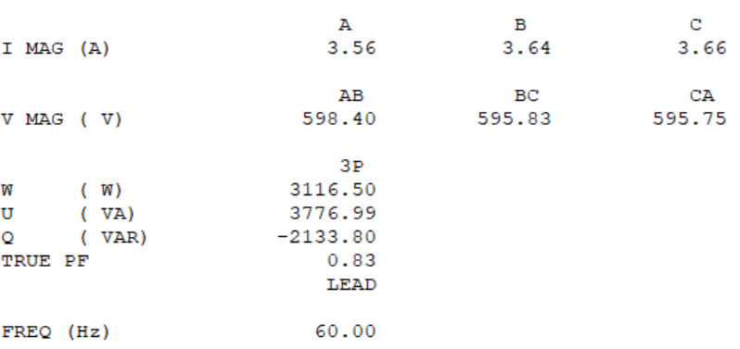

*Figure 28: Meter Measurement*

From the above figure, the measured reactive power is -2133Var.

| Power | Desired | Measured | Error |
| --- | --- | --- | --- |
| Real | 3000W | 3116W | 3.9% |
| Apparent | 3750VA | 3776 VA | 0.7% |
| Reactive | -2250Var | -2133Var | 5.2% |

From the above calculations, the measured real, apparent, and reactive power are as expected and within a reasonable tolerance.

### Overexcited 750W

$Q_{Reactive}=0.5\%*150kVA=750Var$

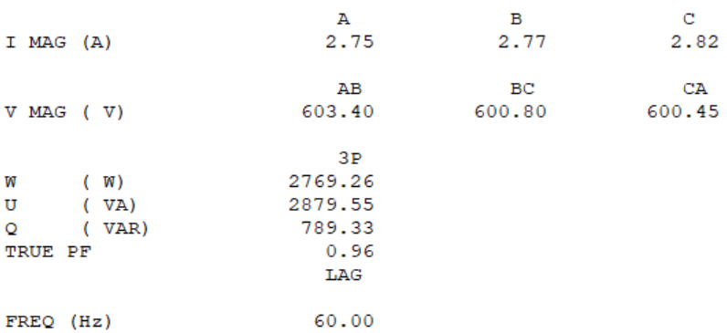

*Figure 28: Meter Measurement*

From the above figure, the measured reactive power is 789Var.

| Power | Desired | Measured | Error |
| --- | --- | --- | --- |
| Real | 3000W | 2769W | 7.7% |
| Apparent | 3092VA | 2879VA | 6.9% |
| Reactive | 750Var | 789Var | 5.2% |

From the above calculations, the measured real, apparent, and reactive power are as expected and within a reasonable tolerance.

### Overexcited 1500W

$Q_{Reactive}=-1\%*150kVA=-1500Var$

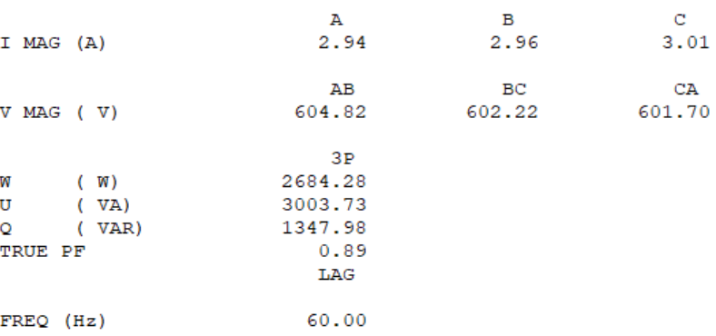

*Figure 29: Meter Measurement*

From the above figure, the measured reactive power is 1347 Var.

| Power | Desired | Measured | Error |
| --- | --- | --- | --- |
| Real | 3000W | 2684W | 10.5% |
| Apparent | 3354VA | 3003 VA | 10.4% |
| Reactive | 1500Var | 1347 Var | 10.2% |

From the above calculations, the measured real, apparent, and reactive power are as expected and within a reasonable tolerance.

### Overexcited 2250W

$Q_{Reactive}=-1.5\%*150kVA=-2250Var$

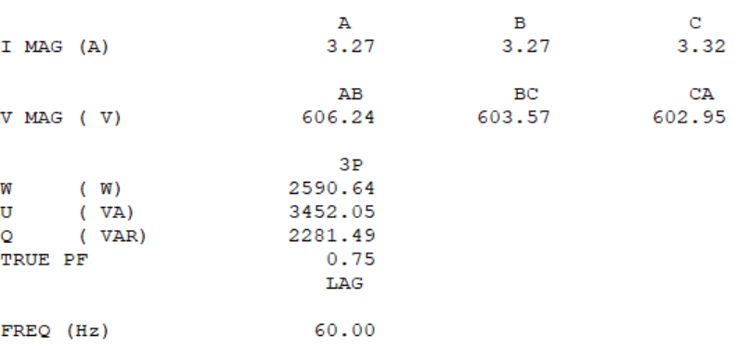

*Figure 30: Meter Measurement*

From the above figure, the measured reactive power is 2281Var.

| Power | Desired | Measured | Error |
| --- | --- | --- | --- |
| Real | 3000W | 2590W | 13.6% |
| Apparent | 3750VA | 3452VA | 8.0% |
| Reactive | 2250Var | 2281Var | 1.3% |

From the above calculations, the measured real, apparent, and reactive power are as expected and within a reasonable tolerance.

# Voltage-Var

“This test verifies the EUT’s operation with voltage-reactive power (volt-var) mode enabled is compliant with 5.3.3 of IEEE Std 1547-2018 during voltage disturbances within the continuous operation range defined in 6.4.2.2 of IEEE Std 1547-2018 with an imbalanced grid (i.e., with a nonzero negative sequence component). This test verifies the EUT’s response to changes in voltage magnitude when connected to an ac test source with a fixed VRef.” (IEEE-SASB Coordinating Committees)

## Objective

In the following test, the Volt-Var mode of the inverter will be tested. From the web UI introduced in section 1.3., the active power is set to be constant. The meter reading will be recorded after the inverter finishes adjusting the output power (i.e. until it reaches a steady state) and is transmitted through the Modbus protocol to MATLAB/Simulink to plot Voltage v.s. Reactive power plot automatically.

## Setup and procedure

On the RT-Lab console mentioned in section 1.1, the desired 3-phase voltage is set to oscillate between 560V to 640V RMS slowly(<0.2V/s) to test how the inverter reacts to a change in voltage.

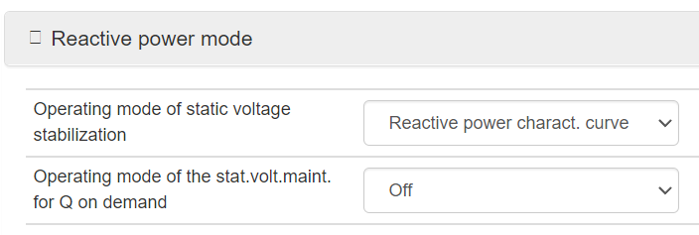

*Figure 31: Reactive Power Mode*

The Operating mode of static voltage stabilization is set to the Reactive power characteristic curve.

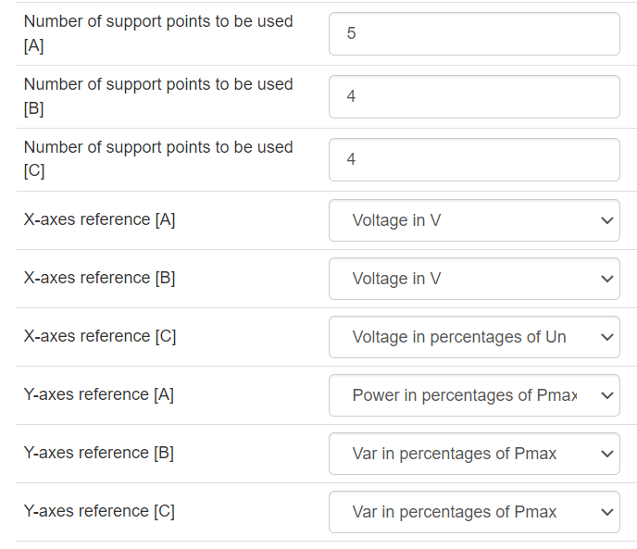

*Figure 32: Characteristic Curve Configuration*

Curve B is used to set the Volt-Var curve, The desired volt-var curve has 4 points in the plot. Thus the number of pints used is set to 4. The X-axes reference is set to voltage and the Y-axes reference is set to Var in the percentage of Pmax.

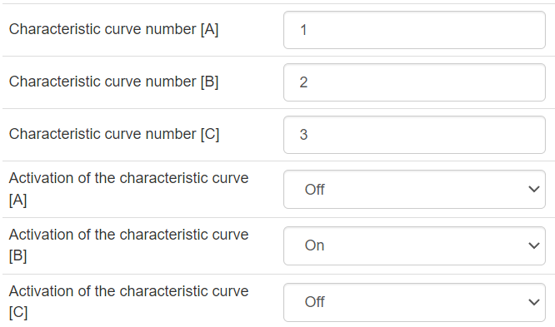

*Figure 33: Curve Selection*

Curve number 2 is selected to be characteristic curve B and only the activation for curve B is turned on.

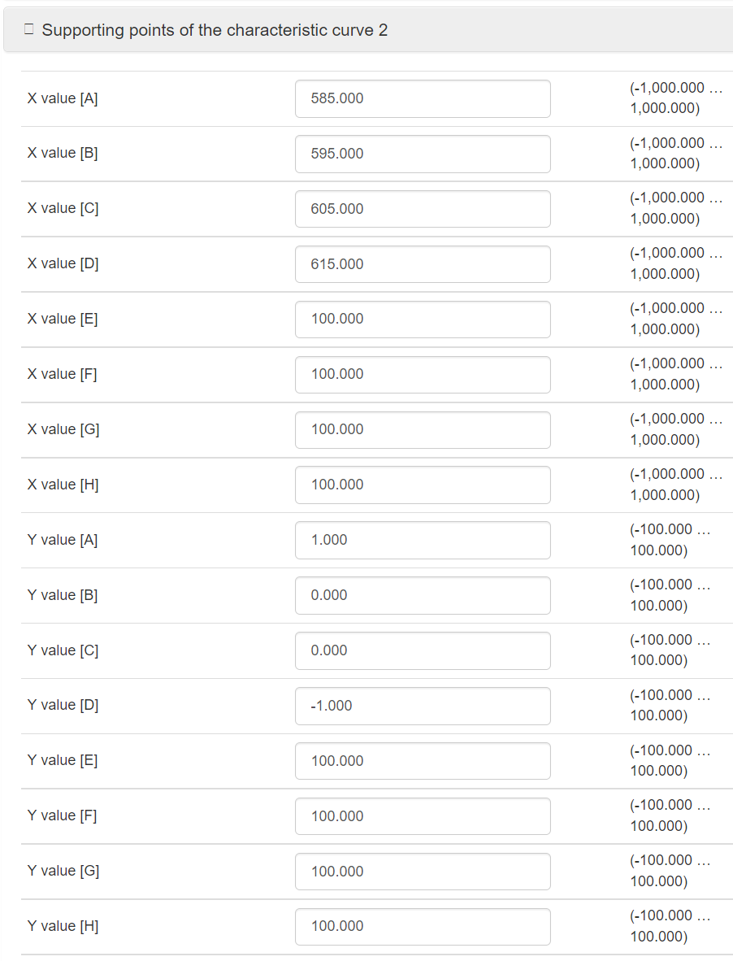

*Figure 34: Curve Point Setting*

Since only 4 points are used, only the first 4 points of X and Y values are set.

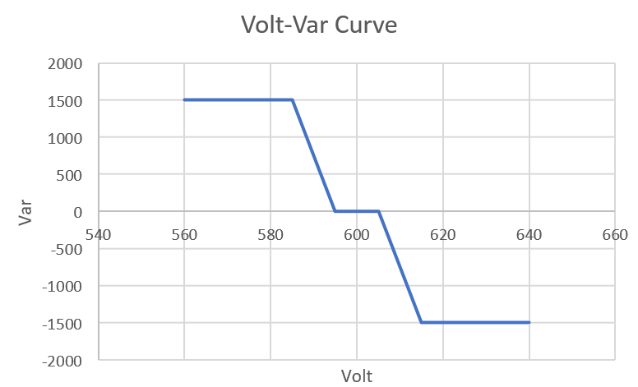

*Figure 35: Desired Characteristics Curve*

The above curve is set as the volt-var behavior when the inverter detects a change in voltage.

## Result

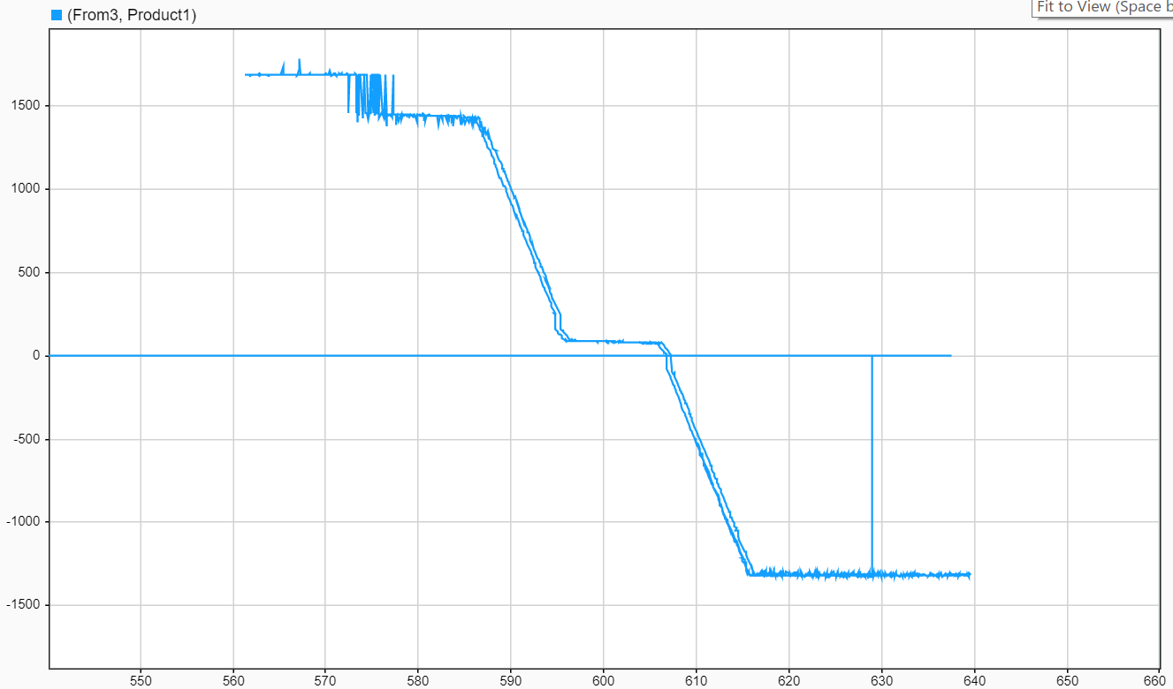

*Figure 36: Measured Curve*

The above figure is plotted in MATLAB with data collected from the meter. The overall volt-var mode performance is consistent with our expectations as we compare the measured volt-var curve to the desired one. The reactive power is non-zero when the voltage swings between 595V to 600V. This is expected since meter errors always exist in the experiment setup. The power instability when voltage swings between 570V to 590V is caused by the coupling that exists between the DC power supply and the inverter which needs to be investigated further.

# Voltage-Watt

“This test verifies the EUT’s operation with voltage-active power (volt-watt) mode enabled is compliant with 5.4.2 of IEEE Std 1547-2018. This test verifies the EUT’s response to changes in voltage magnitude when connected to an ac test source. This test is optional for Category A equipment. ” (IEEE-SASB Coordinating Committees)

## Objective

In the following test, the Volt-Watt mode of the inverter will be tested. From the web UI introduced in section 1.3, the reactive power is set to zero. The meter reading will be recorded after the inverter finishes adjusting the output power(reach steady state) and transmitted through Modbus protocol to MATLABSimulink to plot Voltage v.s. Active power figure automatically.

## Setup and procedure

On the RT-Lab consol mentioned in section 1.1, the desired 3-phase voltage is set to oscillate between 578V to 631V RMS slowly(<0.2V/s) to test how the inverter reacts to change of voltage.

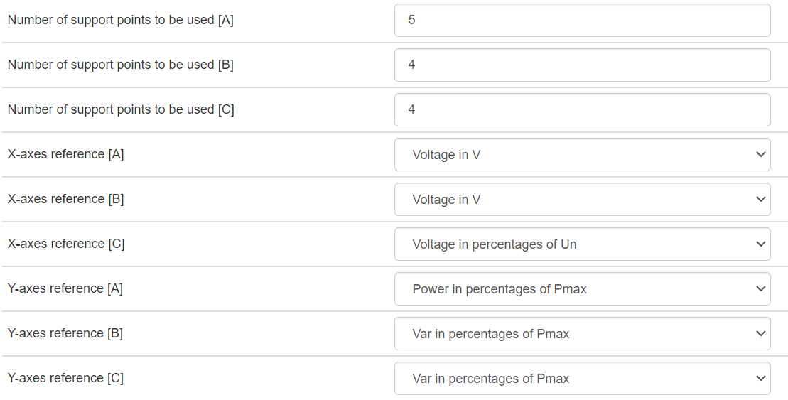

*Figure 37: Characteristic Curve Configuration*

Curve A is used to set the Volt-Watt curve, The desired volt-var curve has 5 points in the plot. Thus the number of pints used is set to 5. The X-axes reference is set to voltage and the Y-axes reference is set to power in the percentage of Pmax.

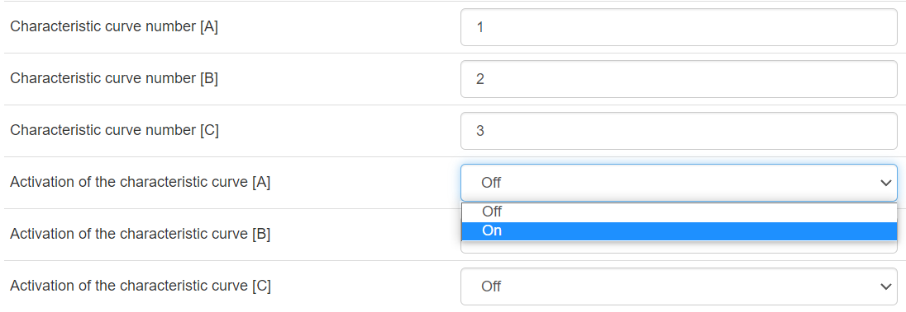

*Figure 38: Curve Selection*

Curve number 1 is selected to be characteristic curve A and only the activation for curve A is turned on.

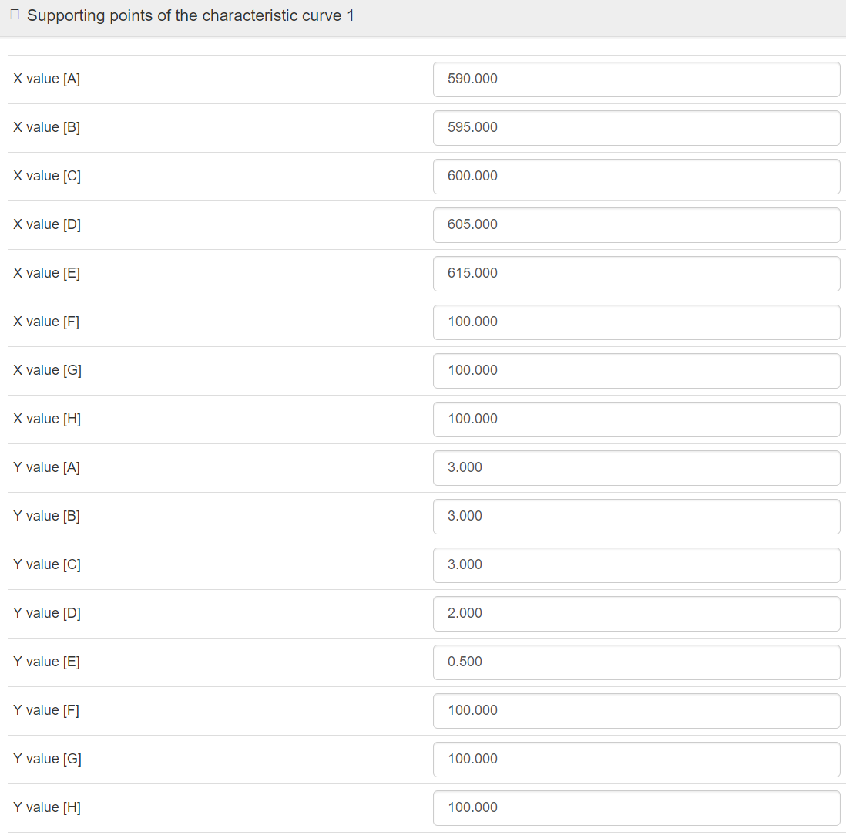

*Figure 39: Curve Point Setting*

Since only 5 points are used, only the first 5 points of X and Y values are set.

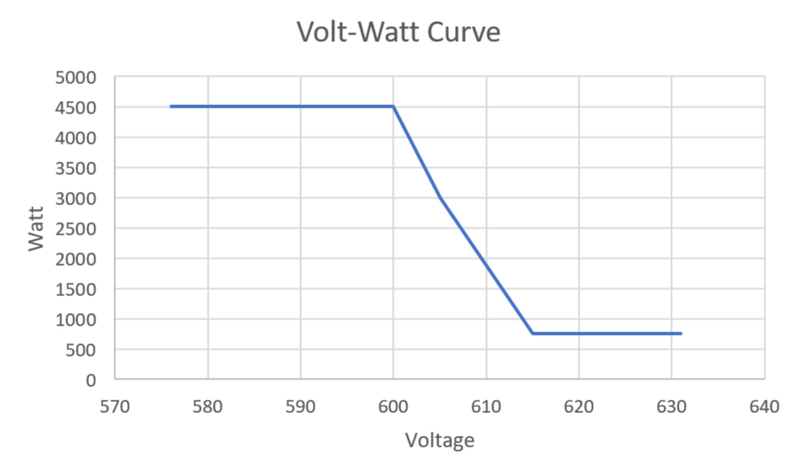

*Figure 40: Desired Characteristive Curve*

The above curve is set as the Volt-Watt behavior when the inverter detects a change in voltage.

## Result

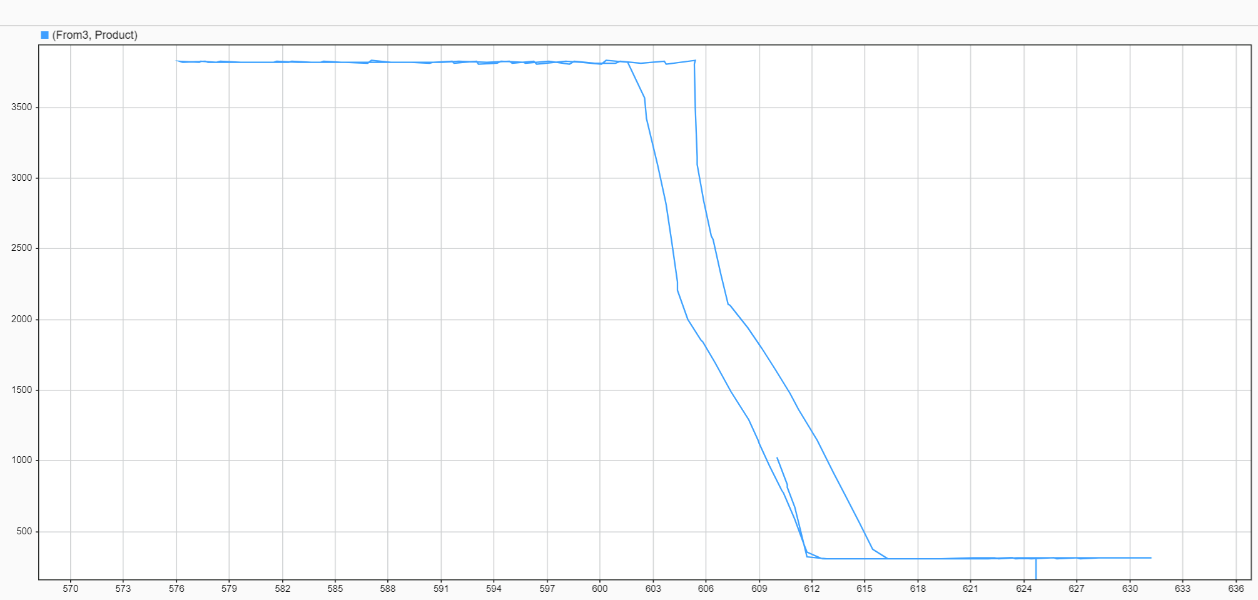

*Figure 41: Measured Curve*

The above figure is plotted in MATLAB with data collected from the meter. The overall vol-watt mode performance is consistent with our expectation as we compare the measured volt-watt curve to a desired one. The hysteresis is noticeable in the above figure, which is not mentioned in the setting of the inverter. Further investigation is needed to find out the cause of this hysteresis.

# Voltage Ride Through

“The low-voltage ride-through (LVRT) test verifies the ability of the EUT to ride through voltage sags without tripping in accordance with the requirements in 6.4.2 of IEEE Std 1547-2018. ” (IEEE-SASB Coordinating Committees)

## Objective

In the following test, the High/Low voltage ride through of the inverter will be tested. From the web UI introduced in section 1.3., the active power is set to 3kW. The meter reading of real power will be recorded as an indicator of whether the inverter is running and transmitted through Modbus protocol to MATLABSimulink to plot Watt v.s. Time figure automatically. Due to equipment limitations, the power amplifier is only able to conduct experiments that have a time scale over 5s. Thus 20s of tripping time is chosen to have enough time for the power amplifier to increase and decrease voltage.

## Setup and procedure

The return to service after grid fault is set to 60 seconds to reduce the time of waiting when the inverter is tripped.

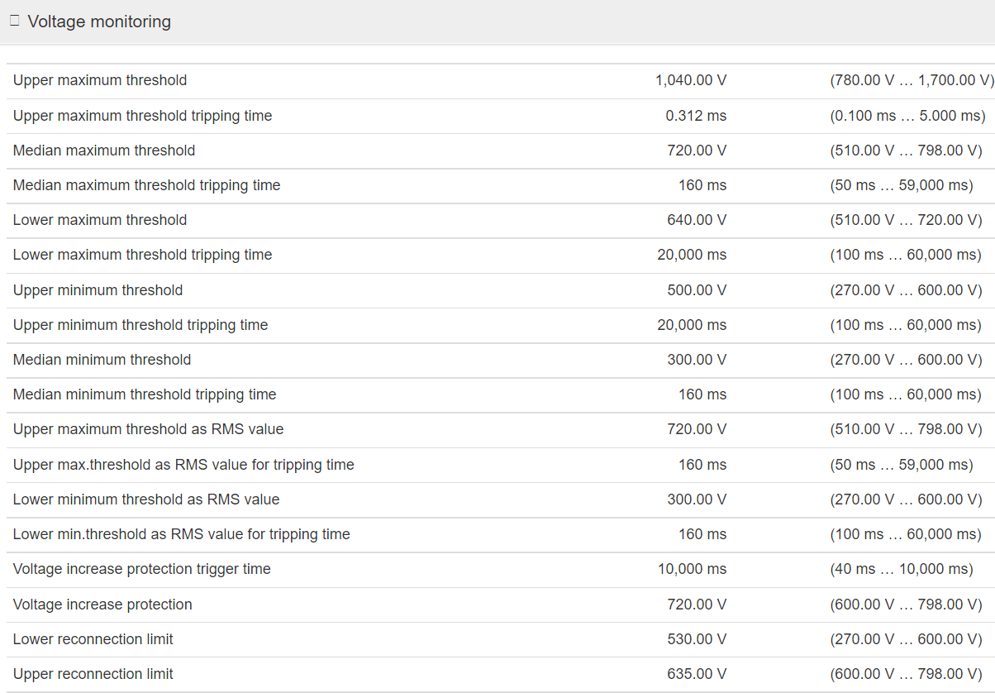

*Figure 42: Voltage Monitoring Setting*

The lower maximum threshold is set to 640V and the tripping time is set to 20s. If the voltage increases above 640V under 20s the inverter should not trip. If the voltage increases above 640V over 20s the inverter should The Upper minimum threshold is set to 500V and the tripping time is set to 20s. If the voltage decreases below 500V under 20s, the inverter should keep operating.

## Result

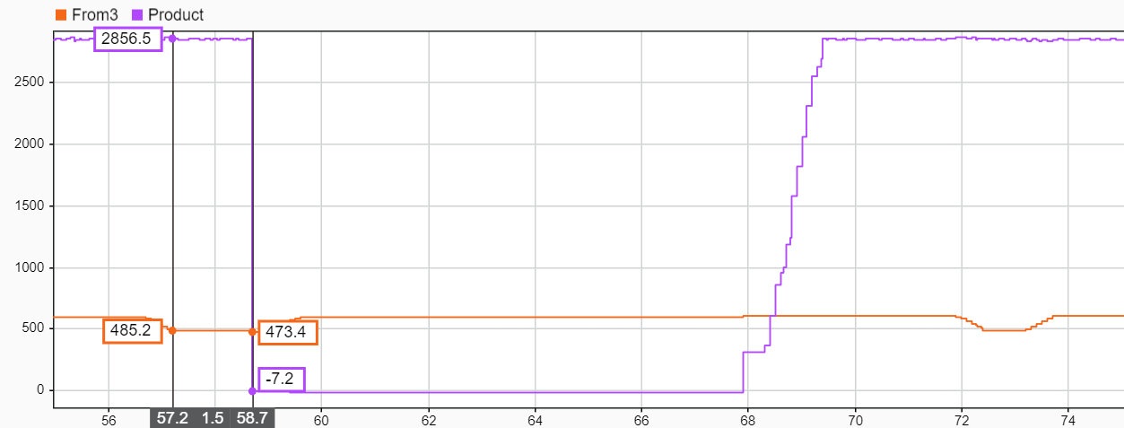

*Figure 43: Purple-Active Power Orange-Voltage*

The console(MATLAB) to control the opal-RT is running on a laptop that can not catch up with the simulator’s speed. Thus, plotting software in MATLAB is not in real-time with the simulator, instead, it is a routine that post-processes the results from the experiments. Consequently, the time axis in the measurements in the above figure needs to be scaled by a factor of 13.3(one second in the above figure is 13.3s in real life). The voltage dropped under 500V at 57.2s and the inverter’s power reduced to 0 at 58.7s. From the above figure, we can see the tripping time is 1.5*13.3=19.5s which is close to the expected value.

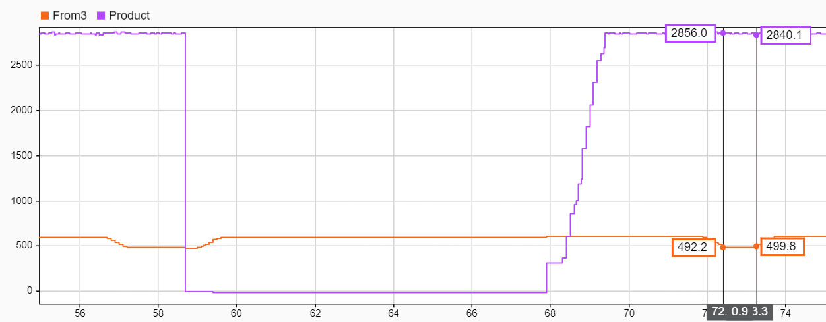

*Figure 44: Purple-Active Power Orange-Voltage*

From the above figure, the inverter starts ramping up power at 68s. The voltage dropped below 500V at 72s and increased above 500V after 12s and the inverter’s power was maintained at the desired value.

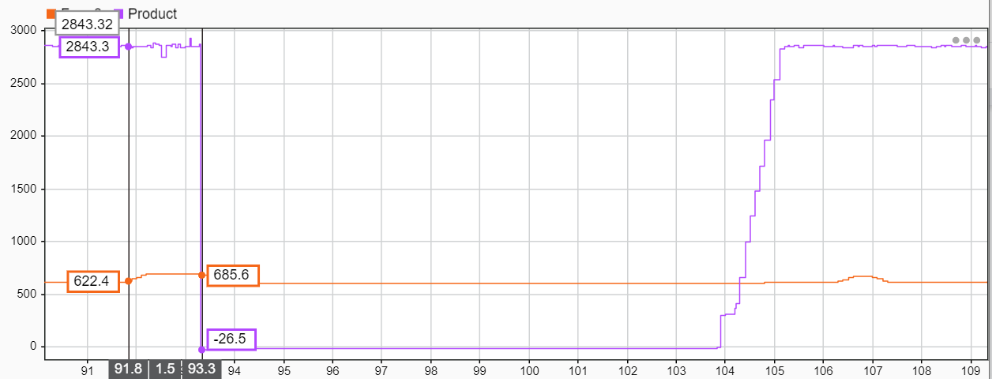

*Figure 45: Purple-Active Power Orange-Voltage*

The voltage increases over 640V at 92s and the inverter’s power is reduced to 0 at 93.3s. From the above figure, we can see the tripping time is 1.3*13.3=17.3s which is close to the expected value of 20s.

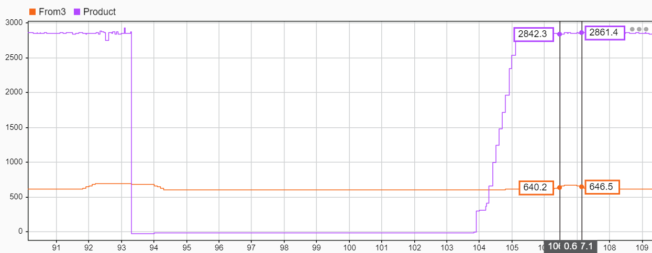

*Figure 46: Purple-Active Power Orange-Voltage*

From the above figure, the inverter starts ramping up power at 104s. The voltage rises above 640V at 106.5s and decreases below 640V after 8s and the inverter’s power is maintained at the expected value.

# Return to Service

## Objective

According to IEEE Std 1547-2020, a 5 min wait after the inverter receives power is necessary to keep maintenance personnel's safety and overall power grid stability. In the following test, the amount of time that the inverter waits after tripping due to low grid voltage is tested.

## Setup and procedure

In the following test, the return to service of the inverter will be tested. From the web UI introduced in section 1.3., the active power is set to 3kW. The meter reading of real power will be recorded as an indicator of whether the inverter is running and transmitted through Modbus protocol to MATLABSimulink to plot Watt v.s. Time figure automatically.

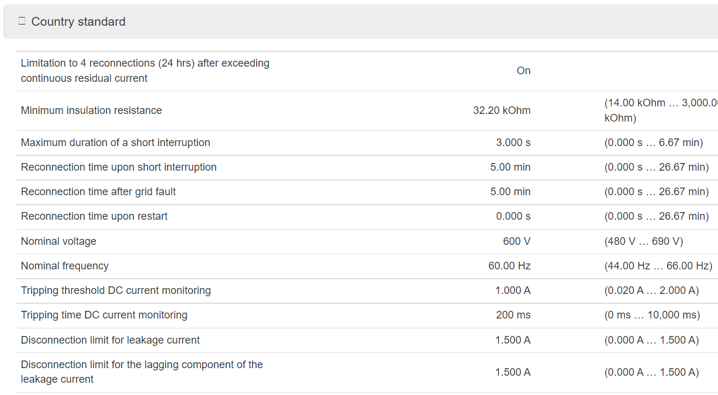

*Figure 47: Country Standard Setting*

The Reconnection time after the grid fault is set to 5 min. The inverter should get back online in 5 min after the inverter receives a normal(600V) grid voltage reading.

## Result

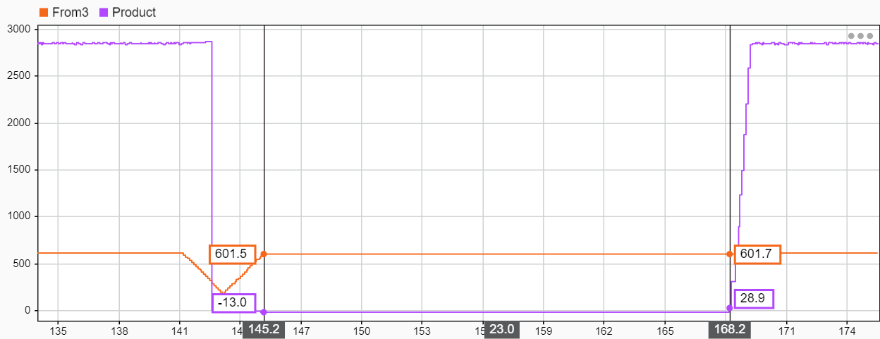

*Figure 43: Purple-Active Power Orange-Voltage*

From the above figure, the inverter receives a nominal voltage at 145.2s and returns to service at 168.2s. The wait duration is 23*13.3=306s which is close to the expected value of 300s.

# Summary of Test Results

In this report, different operating modes of the SMA inverter were tested. Overall the Power Hardware-in-the-Loop Experimental Smart Inverter Testing Environment at RPI passes all the tests documented in this report.

It is worth mentioning that any discrepancies between the expected output of the inverter and what has been measured in the laboratory are likely due to errors introduced by the experimental platform itself. Note that, across all the experiments, the experimental test environment introduced errors that are mainly attributed to the nonlinear behavior of the test equipment and measuring devices (primarily the low-quality voltage and current transformers). An additional aspect to keep in mind, there exists a coupling oscillation between the DC power supply and the inverter which causes instability of output power and needs to be investigated further. Solely from observing the behavior of the inverter, the oscillation only started when the apparent power reached the upper limit of the power amplifier. According to Opal-RT support, the amplifier can be configured differently to reach 15kVA as initially designed. For future experiments, the configuration of the amplifier should be adjusted to adapt experiments that require a higher power rating.

# Bibliography - References

[Korn, G. A., & Wait, J. V. (1978). *Digital continuous-system simulation*. Prentice-Hall.](http://paperpile.com/b/H2sNgl/Pm20)

IEEE-SASB Coordinating Committees. “IEEE Standard Conformance Test Procedures for Equipment Interconnecting Distributed Energy Resources with Electric Power Systems and Associated Interfaces.” *IEEE 1547.1-2020*, 2020, https://standards.ieee.org/ieee/1547.1/6039/.